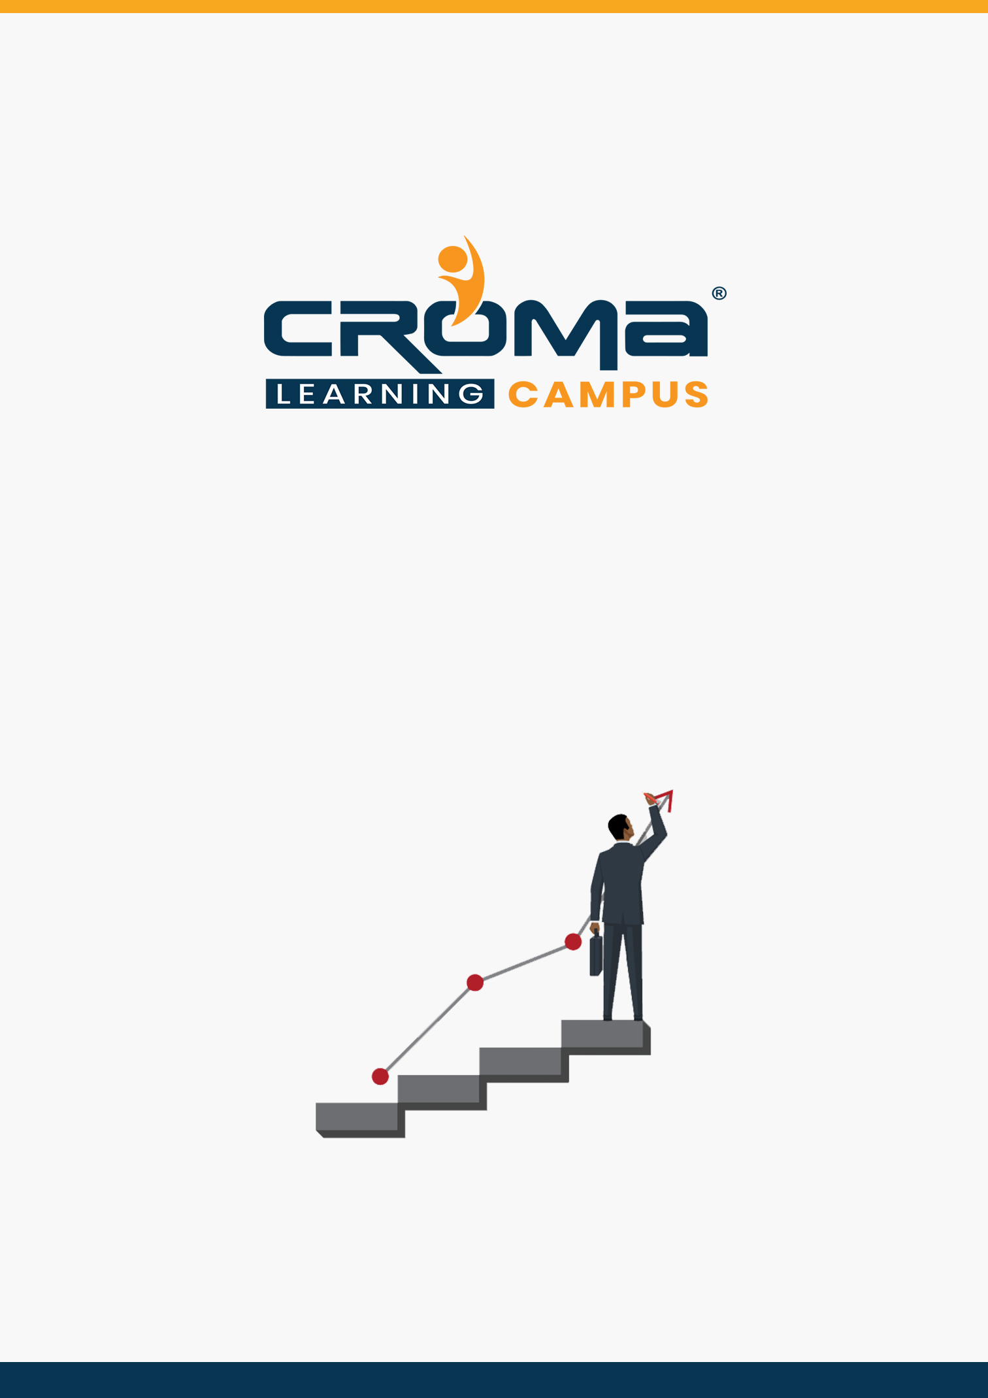

**AZ-203 Developing Solutions for Microsoft Azure Training Curriculum**

**STRUCTURE**

**www.cromacampus.com | helpdesk@cromacampus.com | +91-120-4155255**

**AZ 203 Developing Solutions for Microsoft Azure Training Curriculum**

*“Learn building, managing, and securing Microsoft Azure solutions with our detailed curriculum plan.”*

**Course Objectives:**

* Prepare yourself for the certification exam and clear your certification exam in the first attempt
* Add an attractive credential in your resume that is really appreciated by Companies.
* Improve your overall Cloud management skills, azure development skills, and explore more job prospects with better salary packages.
* Boost your social media profiles especially LinkedIn by adding this certification and become one of the top persons to be chosen by industries.

**AZ 203 Certification Training Description:**

Our AZ-203 “Developing Solutions for Microsoft Azure” certification Training is geared towards Azure Developers who design and build cloud solutions such as applications and services. They participate in all phases of development, from solution design, to development and deployment, to testing and maintenance. They partner with cloud solution architects, cloud DBAs, cloud administrators, and clients to implement the solution.

***Here are some strong reasons why should you consider this certification course.***

* Validate your technical skills like storage, networking, compute, security, and other Cloud operations on Microsoft Azure.
* Validate your development skills and showcase your expertize in building cloud solutions, apps, and services.
* Top-paying info-tech certification in the world.
* It provides you with global recognition for your knowledge, skills, and experience.
* The organization looks for those who know Oracle Cloud, AWS, Azure, etc.

**Prerequisites for the Certification Exam:**

* To attempt for this certification, you should be proficient in developing apps and services by using Azure tools and technologies, including storage, security, compute, and communications. Basically, you must have Azure admin skills or you are advised to attempt for *AZ 103 Azure admin Associate Certification* exam first before you attempt for the AZ 203, Azure Developer Associate.
* Also, you must have at least one year of experience developing scalable solutions through all phases of software development and be skilled in at least one cloud-supported programming language.

**Necessary Details about Certification You must Know**

* Certification Name – AZ-203 Developing Solutions for Microsoft Azure
* Exam Duration: 150 minutes
* Number of Questions: 40-60
* Passing score: 700 (Out of 1000)
* Exam Cost: USD 165.00
* Validity: 2 years

**Certification Exam Structure:**

* Develop Azure Infrastructure as a Service compute solution (10-15%)
* Develop Azure Platform as a Service compute solution (20-25%)
* Develop for Azure storage (15-20%)
* Implement Azure security (10-15%)
* Monitor, troubleshoot, and optimize solutions (10-15%)
* Connect to and consume Azure and third-party services (20-25%)

**Course Content:**

**Module 1: Develop Azure Infrastructure as a Service Compute Solution**

* Introduction
  + Introduction to Cloud Computing
  + Microsoft Azure Overview
  + Microsoft Azure Services
  + Azure Subscriptions
  + Azure Resource Groups
  + Organizing Azure Resources
  + What are Virtual Machines?
  + Introduction to ARM Templates
  + What are batch Jobs and Azure Batch Services?
  + What is Kubernetes?
* Implement solutions that use virtual machines (VM)
  + provision VMs
  + create ARM templates
  + configure Azure Disk Encryption for VMs
* Implement batch jobs by using Azure Batch Services
  + manage batch jobs by using Batch Service API
  + run a batch job by using Azure CLI, Azure portal, and other tools
  + write code to run an Azure Batch Services batch job
* Create containerized solutions
  + create an Azure Managed Kubernetes Service (AKS) cluster
  + create container images for solutions
  + publish an image to the Azure Container Registry
  + run containers by using Azure Container Instance or AKS

**Module 2: Develop Azure Platform as a Service compute solution**

* Create Azure App Service Web Apps
  + create an Azure App Service Web App
  + create an Azure App Service background task by using Web Jobs
  + enable diagnostics logging
  + create an Azure Web App for Containers
  + monitor service health by using Azure Monitor
* Create Azure App Service mobile apps
  + add push notifications for mobile apps
  + enable offline sync for mobile app
  + implement a remote instrumentation strategy for mobile devices
* Create Azure App Service API apps
  + create an Azure App Service API app
  + create documentation for the API by using open source and other tools
* Implement Azure functions
  + implement input and output bindings for a function
  + implement function triggers by using data operations, timers, and webhooks
  + implement Azure Durable Functions
  + create Azure Function apps by using Visual Studio
  + implement Python Azure Functions

**Module 3: Develop for Azure storage**

* Introduction
  + Azure Storage
  + Azure Storage Replication
  + Azure Storage Explorer
  + Attach or Detach an External Storage Account
  + Shared Access Signatures (SAS)
  + Attach a Storage Account using SAS
  + Azure Blob Storage
  + Azure File Storage
  + Azure Queue Storage
* Azure Table Storage Develop solutions that use storage tables
  + design and implement policies for tables
  + query table storage by using code
  + implement partitioning schemes
* Develop solutions that use Cosmos DB storage
  + create, read, update, and delete data by using appropriate APIs
  + implement partitioning schemes
  + set the appropriate consistency level for operations
* Develop solutions that use a relational database
  + provision and configure relational databases
  + configure elastic pools for Azure SQL Database
  + create, read, update, and delete data tables by using code
  + provision and configure Azure SQL Database serverless instances
  + provision and configure Azure SQL and Azure PostgreSQL Hyperscale instances
* Develop solutions that use blob storage
  + move items in Blob storage between storage accounts or containers
  + set and retrieve properties and metadata
  + implement blob leasing
  + implement data archiving and retention
  + implement Geo Zone Redundant Storage

**Module 4: Implement Azure security**

* Implement authentication
  + implement authentication by using certificates, forms-based authentication, or tokens
  + implement multi-factor or Windows authentication by using Azure AD
  + implement OAuth2 authentication
  + implement Managed identities/Service Principal authentication
  + implement Microsoft identity platform
* Implement access control
  + implement CBAC (Claims-Based Access Control) authorization
  + implement RBAC (Role-Based Access Control) authorization
  + create shared access signatures
* Implement secure data solutions
  + encrypt and decrypt data at rest and in transit
  + create, read, update, and delete keys, secrets, and certificates by using the KeyVault API

**Module 5: Monitor, troubleshoot, and optimize solutions**

* Develop code to support scalability of apps and services
  + implement autoscaling rules and patterns (schedule, operational/system metrics,
  + singleton applications)
  + implement code that handles transient faults
  + implement AKS scaling strategies
* Integrate caching and content delivery within solutions
  + store and retrieve data in Azure Redis cache
  + develop code to implement CDN’s in solutions
  + invalidate cache content (CDN or Redis)
* Instrument solutions to support monitoring and logging
  + configure instrumentation in an app or service by using Application Insights
  + analyze and troubleshoot solutions by using Azure Monitor
  + implement Application Insights Web Test and Alerts

**Module 6: Connect to and consume Azure and third-party services**

* Develop an App Service Logic App
  + create a Logic App
  + create a custom connector for Logic Apps
  + create a custom template for Logic Apps
* Integrate Azure Search within solutions
  + create an Azure Search index
  + import searchable data
  + query the Azure Search index
  + implement cognitive search
* Implement API management
  + establish API Gateways
  + create an APIM instance
  + configure authentication for APIs
  + define policies for APIs
* Develop event-based solutions
  + implement solutions that use Azure Event Grid
  + implement solutions that use Azure Notification Hubs
  + implement solutions that use Azure Event Hub
* Develop message-based solutions
  + implement solutions that use Azure Service Bus
  + implement solutions that use Azure Queue Storage queues

**Module 13: Placement Guide**

* Tips to clear an Interview
* Common Interview questions and answers
* AZ 203 Interview Questions and Answers
* Resume Building Guide
* Attempt for AZ 203 Global Certification Exam
* Start applying for Jobs